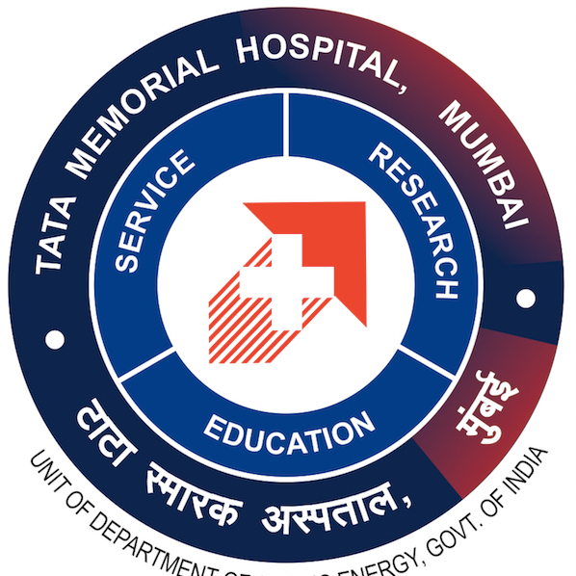
TATA MEMORIAL CENTRE
TATA MEMORIAL HOSPITAL
DEPARTMENT OF NURSING

SYLLABUS
Crash Course in Oncology Nursing
1 Month Course
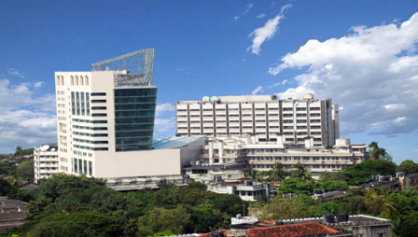
TATA MEMORIAL HOSPITAL
Dr. Ernest Borges Road, Parel, Mumbai, Maharashtra, India- 400 012.
Tel. +91-22- 24177000, 24177300, 24161413, Fax: +91-22-24146937

INTRODUCTION:
The TATA MEMORIAL CENTER is the national center under the administrative responsibility of the department of Atomic Energy engaged in comprehensive patient care, high quality training and innovative cancer research. It is the premier hospital with extensive facilities for total care of patients in the field of chemotherapy including bone marrow transplant, surgery and radiotherapy.
Training and education is a major focus area of Tata Memorial Center. The center believes that specialized training in Oncology Nursing will help trained nurses to take keen interest with confidence and responsibility in patients’ care including patients’ education and also for rehabilitating victims of cancer in hospitals and community.

The center firmly believes that building up a cadre of specialists in oncology nursing will help regional cancer centers, cancer hospitals, clinics, hospices to find enough manpower in due course to take up the challenges resulting from the large incidence of cancer which is reorganized as one of major health problems.

AIM:
The aim of the course is to upgrade the knowledge and skill of trained nurses to create a cadre of specially trained and experienced nurses in oncology nursing with high professional capabilities and expertise to provide comprehensive nursing care to patient with cancer.
OBJECTIVES:
At the course, the learner will be able to
- Acquire knowledge of cancer and needs of cancer patients
- Develop knowledge regarding modalities of treatment including chemotherapy in detail for cancer patients.
- Develop knowledge and skill in administering chemotherapeutic drugs and blood products.
- Identify the side effects of treatment and to provide appropriate measure to relive those side effects.
- Gains skill in various specialized nursing procedure required to render comprehensive care to patient with cancer.
- Develop competency in providing care to patient with recent infection prevention practices.

ELIGIBILITY FOR ADMISSION
A candidate must fulfill following eligibility criteria;
- Must be a Registered nurse and Registered midwife and should be registered in the state nursing council.
- Should be actively engaged in patient care for a minimum of one year.
- Should be proficient in reading, writing and speaking in English.

DRESS CODE:Nursing uniforms with anIdentification card is compulsory for the course duration.

COURSE DURATION:Three months
- 8 hours per day x 6 days per week x 4 weeks =192hours
- Per day :6 hours clinical and 2 hours theory = 8 hours per day
- Theory: 22 hours
- Practical: 170 hours
- Examination: 2 hours

COURSE OF INSTRUCTION
Unit No. | Title of the Module | Hours of Instruction
Unit No. | Title of the Module | Theory | Practical
I | Overview of cancer | 2 | -
II | Chemotherapy and nursing care | 14 | 134
III | Infection Prevention | 3 | -
IV | Emergencies in Cancer Care | 3 | 36
 | Total Hours | 22 | 170

COURSE PLANNING – THEORY

Unit | Hrs | Content | Teaching Learning Activities
I | 2 | Overview of cancer
I | 1 | - Cell cycle, types of tumor, benign Vs malignant | Lecture cum discussion
I | 1 | - Diagnosis of cancer | Lecture cum discussion
II | 14 | Chemotherapy and Nursing care
II | 1 | - Meaning , Principles, types, protocols | Lecture cum discussion
II | 1 | - Alkylating chemotherapy drugs, Nitrosoureas | Lecture cum discussion
II | 1 | - Antimetabolites | Lecture cum discussion
II | 1 | - Anti tumour antibiotics | Lecture cum discussion
II | 1 | - Plant Alkaloids and its types | Lecture cum discussion
II | 1 | - Hormonal Agents, Immunotherapy, targeted therapy | Lecture cum discussion
II | 1 | - Targeted therapy | Lecture cum discussion
II | 1 | - Routes of chemotherapy administration | Lecture cum discussion
II | 2 | - PICC and Port access and care | Lecture, demonstration
II | 1 | 3.10. Preparation of Chemotherapy medication | Lecture, demonstration
II | 1 | 3.11. Side effects and its management | Lecture cum discussion
II | 1 | 3.12. Extravasation management | Lecture, demonstration
II | 1 | 3.13 Occupational Safety: Biosafety cabinet and PPE
III | 3 | Infection Prevention
III | 1 | 6.1. Infection control protocols, reverse barrier nursing | Lecture, demonstration
III | 1 | 6.2. Communicable diseases in Cancer, isolation units | Lecture cum discussion
III | 1 | 6.3. Care of febrile Neutropenia and sepsis | Lecture cum discussion
III | 1 | 6.4. Housekeeping policies, spill management | Lecture, demonstration
IV | 3 | Emergencies in Cancer Care
IV | 1 | 8.2. Cardiac arrest and CPCR | Lecture, demonstration
IV | 1 | 8.3. Bleeding, carotid burst,SVC syndrome | Lecture cum discussion
IV | 1 | 8.4. Tumor lysis syndrome | Lecture cum discussion

CLINICAL EXPERIENCE

Unit | Title of Module | Area of Experience | Hours | Days
III | Chemotherapy and nursing care | Day Care | 36 | 6
III | Chemotherapy and nursing care | Injection Room | 30 | 5
III | Chemotherapy and nursing care | OT – IT MTX administration | 6 | 1
III | Chemotherapy and nursing care | CVAD Clinic | 36 | 6
VIII | Emergencies in Cancer | Casualty | 36 | 6
TOTAL

COURSE PLANNING –PRACTICAL

Unit No. | : | II
Unit Title | : | Chemotherapy and nursing care
Department of experience | : | - Injection Room
Hours per dept. | : | 30hours (6 hours per day x 5 days)
Clinical concepts to be learned |  | C.1 | Countercheck of chemotherapy medications
Clinical concepts to be learned |  | C.2 | Rights of drug administration
Skills to be achieved | : | S.1 | Administration of Injection through S/C route
Skills to be achieved |  | S.2 | Administration of Injection through IM route
Skills to be achieved |  | S.3 | Administration of Injection through IV route - antibiotics
Skills to be achieved |  | S.4 | Operating Biosafety cabinet
Skills to be achieved |  | S.5 | Administration of drugs through IV route - chemotherapy
Department of experience | : | - CVAD clinic
Hours per dept. | : | 36hours ( 6 hours per day x 6 days)
Clinical concepts to be learned | : | C.3 | Types of PICC catheters
Clinical concepts to be learned |  | C.4 | Counseling of patient and relative for PICC insertion
Clinical concepts to be learned |  | C.5 | Procedure of PICC insertion
Clinical concepts to be learned |  | C.6 | Confirming position of PICC on x ray chest
Clinical concepts to be learned |  | C.7 | PICC complications and its management
Skills to be achieved | : | S.6 | PICC Dressing
Skills to be achieved |  | S.8 | Flushing and cap changing
Skills to be achieved |  | S.9 | Infusion set changing
Skills to be achieved |  | S.10 | Blood collection
Skills to be achieved |  | S.11 | Port access and Deaccess
Skills to be achieved |  | S.12 | PICC removal
Department of experience | : | - Day Care
Hours per dept. | : | 36hours ( 6 hours per day x 6 days)
Clinical concepts to be learned | : | C:8 | Checking the protocol
Clinical concepts to be learned |  | C:9 | Confirming patients eligibility to receive chemotherapy
Clinical concepts to be learned |  | C:33 | Management of Extravasation
Clinical concepts to be learned |  | C:34 | Spill management
Clinical concepts to be learned |  | C:35 | Management of reaction to chemotherapy
Skills to be achieved | : | S.22 | Operating Biosafety cabinet
Skills to be achieved |  | S.23 | Calculation of drug doses
Skills to be achieved |  | S:24 | Chemotherapy drug preparation
Skills to be achieved |  | S.25 | Calculation of fluid administration – drops / min
Skills to be achieved |  | S:26 | Administration of premedication
Skills to be achieved |  | S:27 | Administration of chemotherapy though PICC
Skills to be achieved |  | S:28 | Administration of chemotherapy through port
Skills to be achieved |  | S:29 | Preparation of elastomeric pump
Department of experience | : | - GJB OT
Hours per dept. |  | 6hours ( 6 hours per day x 1 days)
Clinical concepts to be learned | : | C:38 | Action of Inj. Methotrexate
Clinical concepts to be learned |  | C:39 | Reason for Intrathecal injection
Skills to be learned | : | S: 36 | Assisting for Administration of Intrathecal Methotrexate
Skills to be learned |  | S: 37 | Post procedure monitoring of patient
Skills to be learned |  | S:38 | Assisting for Bone Marrow aspiration and Biopsy
Unit No. | : | IV
Unit Title | : | Emergencies in Cancer
Area of experience | : | - Casualty
Hours per dept. | : | 36hours (5 hours/ day x 6 days)
Skills to be achieved |  | S:48 | CPCR

